Project Name: Jk Accounting Software
Version: 1.0.0.0 (Under development)
Platform: Windows
Front-end: C#.Net (Framework 4.5)
Back-end: MS SQL Server 2014
Architecture: Desktop Application/Client and Server Architecture
Public Repository: https://github.com/Jake-Oandasan/Jk-Accounting-Software
Description:
An accounting system which can cater business transaction in the Philippines primarily to record transactions such as Journal Voucher, Purchase Voucher, Sales Voucher, Cash Receipt Voucher and Cash Disbursement Voucher. It is also able to generate reliable Financial Reports such as Balance Sheet, Income Statement and Cash Flow report and also reports for auditing purposes such as General Ledger, Subsidiary Ledger and Trial Balance.

Purpose:
Currently it is a project as a hobby and basically I just want to explore the .Net technology and features such as visual inheritance, creating custom controls/components, OOP principles in .Net and plugin architecture, and also for me there is no best way to do it other than to create a real life usable application. Also I just want to include it into my resume/portfolio, because I think it is better to show something rather than just explaining it through plain words.

Future Plans:
I think I still have a long way to go before I could finish it because I am just the sole developer for this project, but who knows maybe someday if I would able to finish it maybe I could start something out of it but for now one thing is for sure I’ve learned so much on this project which I could apply on my future work or projects.
SCREENSHOTS
1. The main interface which shows the categories which are Maintenance, Administration, Accounting and Reports.
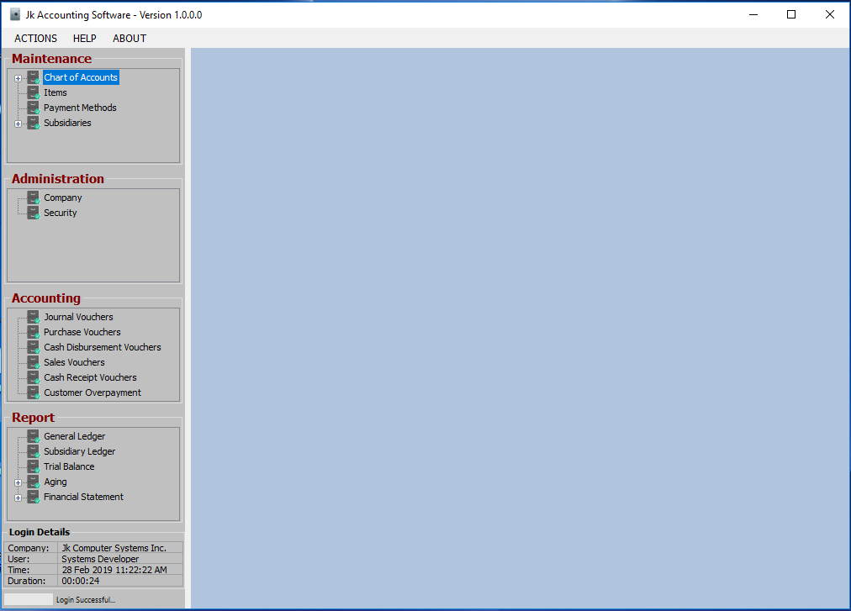
Maintenance – for inputting of supplementary data such as Customer, Employee, Vendor, Chart of Accounts and Others
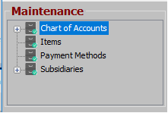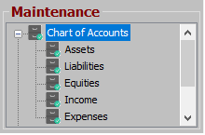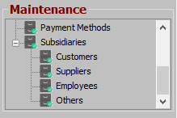

Administration – for assigning of username and password of Users and Company Setup
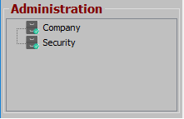

Accounting – for inputting of main transaction vouchers
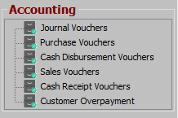

Reports – for showing output such as Financial Reports and Aging
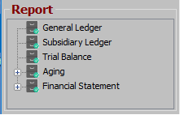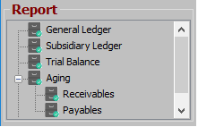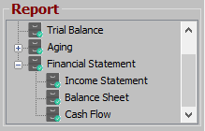
2. To be able to see the transaction list just choose in the Sub Category, as shown below we will use Customer. It will show all the list for the particular transaction, it also has “New” button:
New – if you want to create a new data
Open – to be able to view the highlighted/selected data just by double clicking a certain record
Upon performing the two operations, it will show the module which you can perform inputting new data, viewing or modifying an existing one.
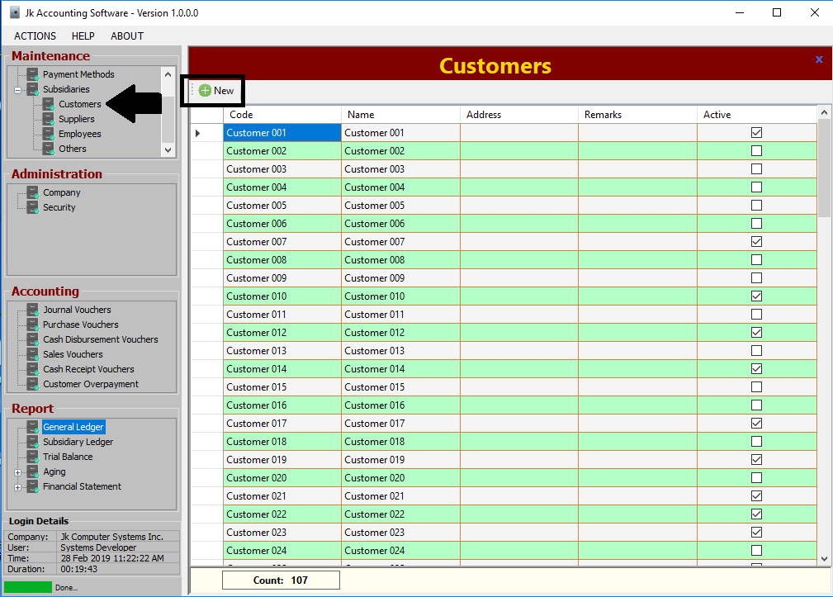
3. Upon creating new transaction, it will show the fields that are required.
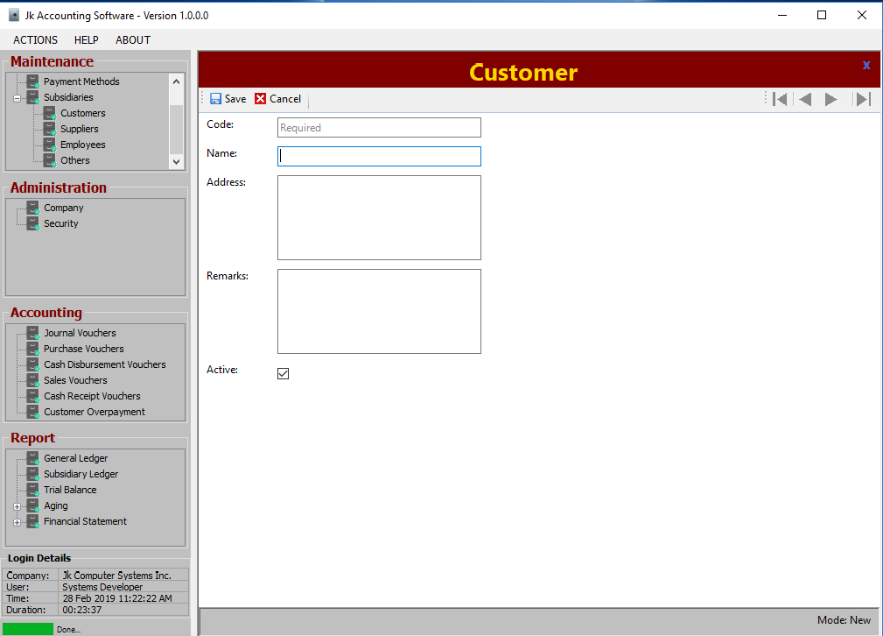

4. Then just fill up the entries and click “Save” button or “Cancel” if you want to cancel the transaction.
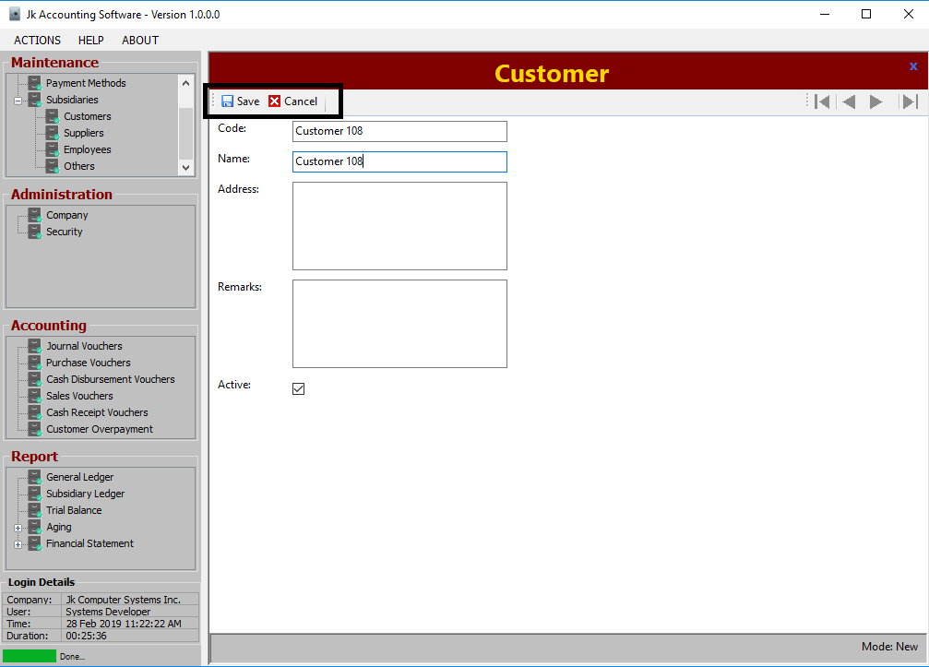

5. Once you clicked “Save” or “Cancel” button the system will ask for a confirmation.
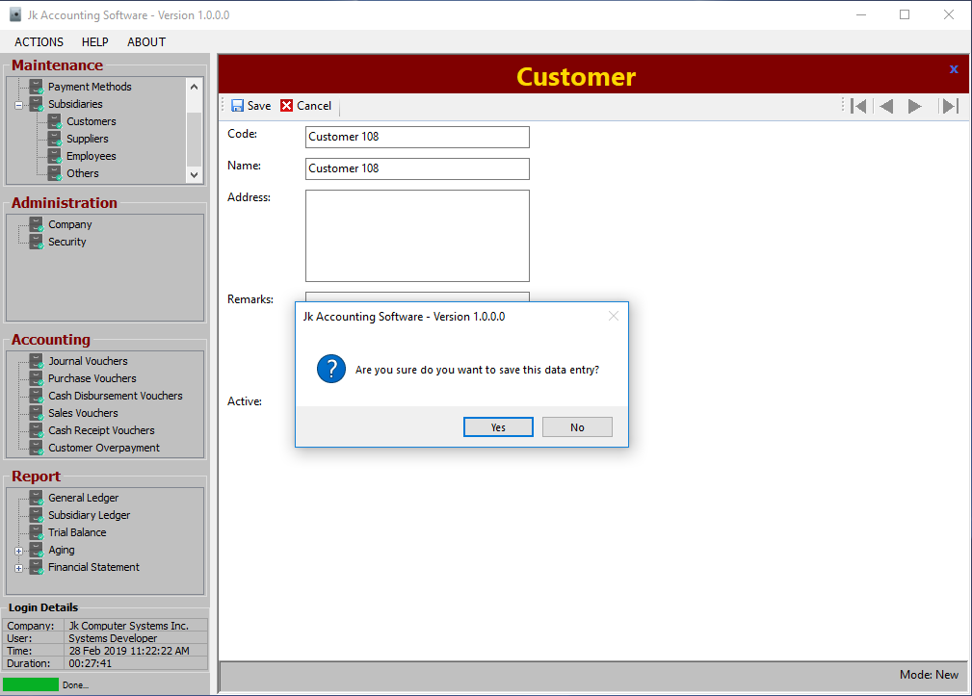
6. Once the data has been saved the system will now disable the inputting fields, but still you could modify it by clicking “Edit” button or clicking “New” button for creating another transaction.
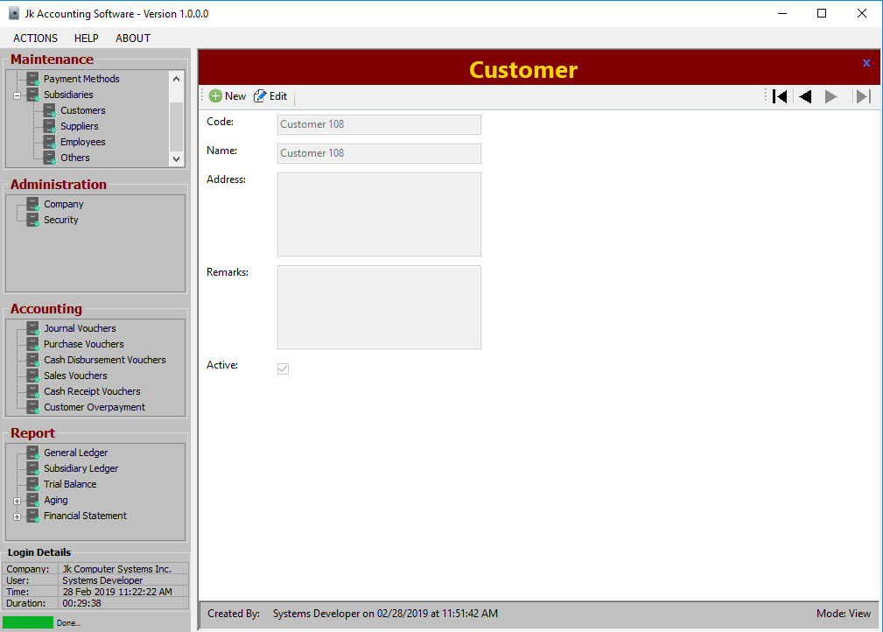
7. The system will also fill up the details such as “Created By” if transaction is newly created and “Modified By” if the transaction is modified. It also shows the current transaction mode such as “New”, “Edit” and “View”, once the transaction is in view mode, the user can navigate the records “First Record”, “Previous Record”, “Next Record” and “Last Record” buttons.
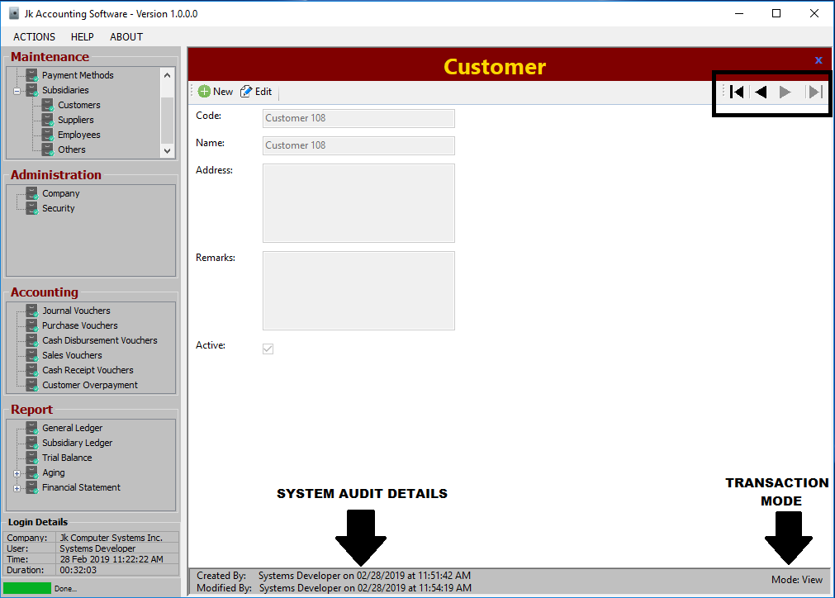
8. The freshly added data will now be available in the list.
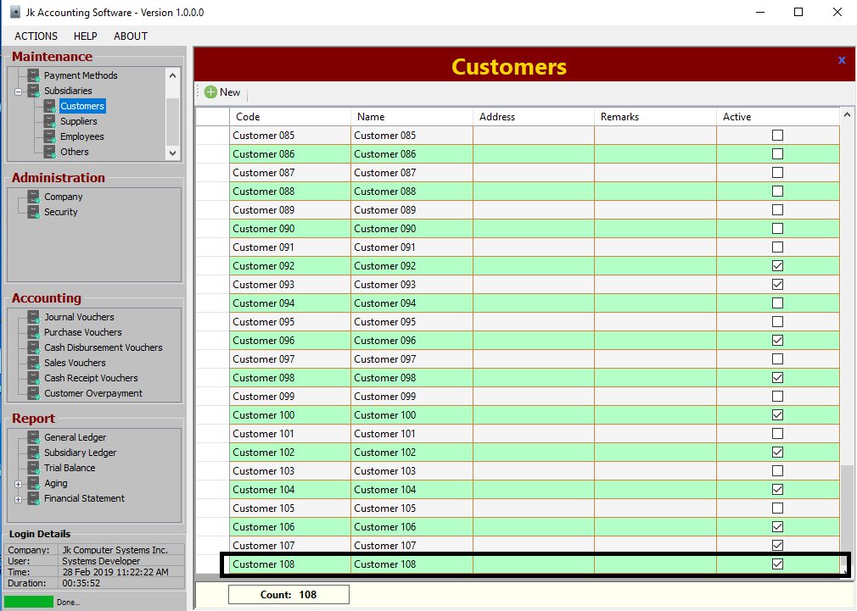
9. Other system information and buttons

Login Details – shows the details of the currently logged in user such as:
Company – company which the user account belongs
User – the username of the account
Time – date and time the user logged on
Duration – length of time the user has logged on the system

System Progress Bar – shows the progress of an existing action such as opening the form, saving or editing of transactions and others.

System Status Text – shows the current action executing by the system such as opening the form, saving or editing of transactions or whether the action is done.

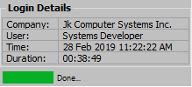

System Menu – shows other system actions such as Log-out, Help, About and others.
Refresh – refreshes the data of the currently open form
Logout – logout’s the current user/closing the application
Restart – reopens the system and back to the login form
Help – opens the help file
About – shows the detail of the system such as Product Name, Product Version, Developer Details and others.

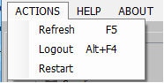

10. Main transactions are the 5 transaction vouchers Sales Vouchers, Cash Receipt Vouchers, Purchase Vouchers, Cash Disbursement Vouchers and Journal Vouchers.

Sales Vouchers – is used to record sales of service or merchandise to a Customer.

Left-most view, creating new transaction
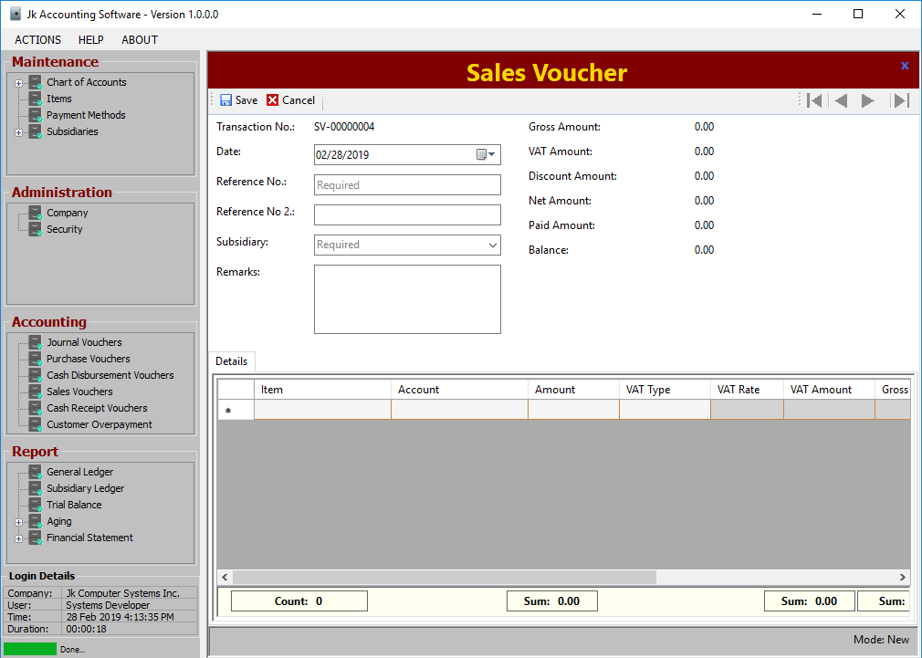
Right-most view, creating new transaction
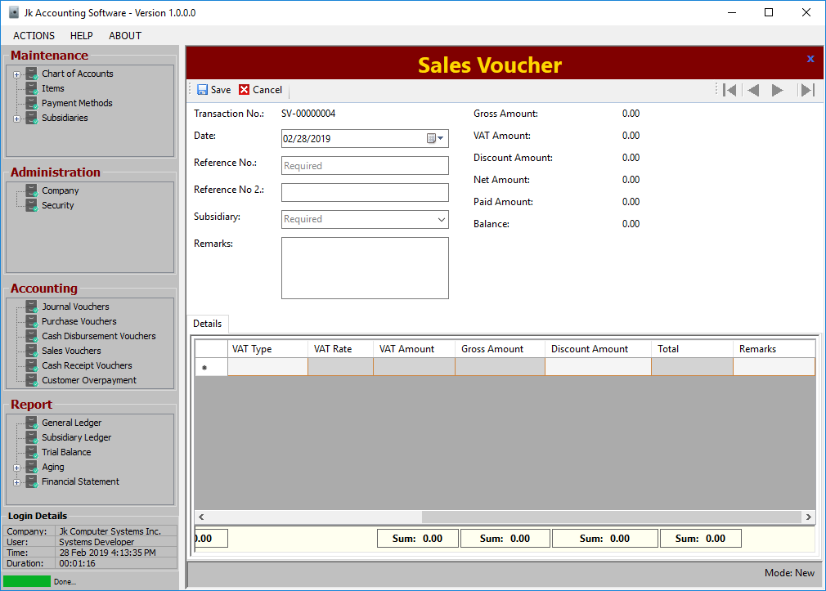

Upon creating new transaction, just input the following:
Reference No – usually this is the control number on the printout
Subsidiary – or the Customer
Item – the product or service to sell
Account – the sales account of the product or service, this will appear on Sales Journal and General Ledger or any accounting related reports.
Amount – or price of the product or service
VAT Type – VAT Inclusive, VAT Exclusive, Non VAT-able and Zero Rated
Discount Amount – to input the discount given to the customer, optional only

Auto computed columns are the following:
VAT Rate – currently default value is 12 or 12%, which is the VAT Rate in the Philippines.
VAT Amount – Amount multiplied by VAT Rate
Gross Amount – If item is VAT Inclusive Amount minus VAT Amount, otherwise Amount
Total – Gross Amount plus VAT Amount minus Discount Amount
Left-most view, encoding of transaction
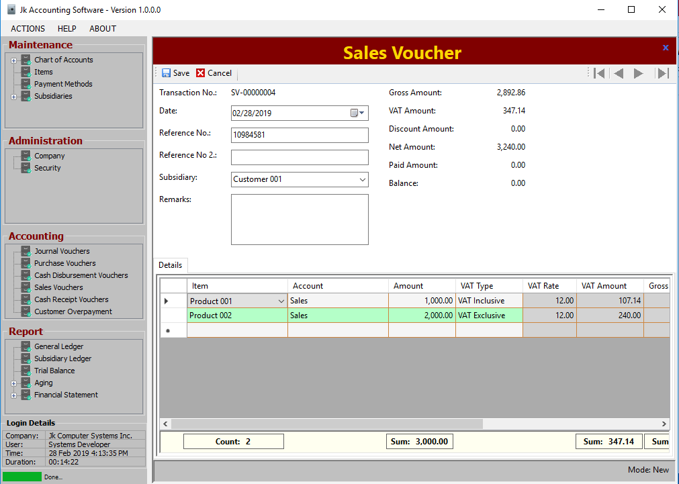
Right-most view, encoding of transaction
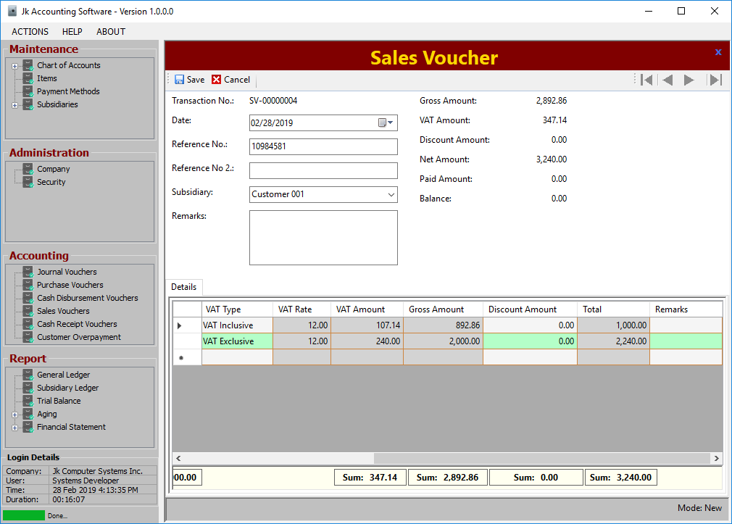
Upon saving, sales journal entry will be automatically generated.

Journal Entry tab
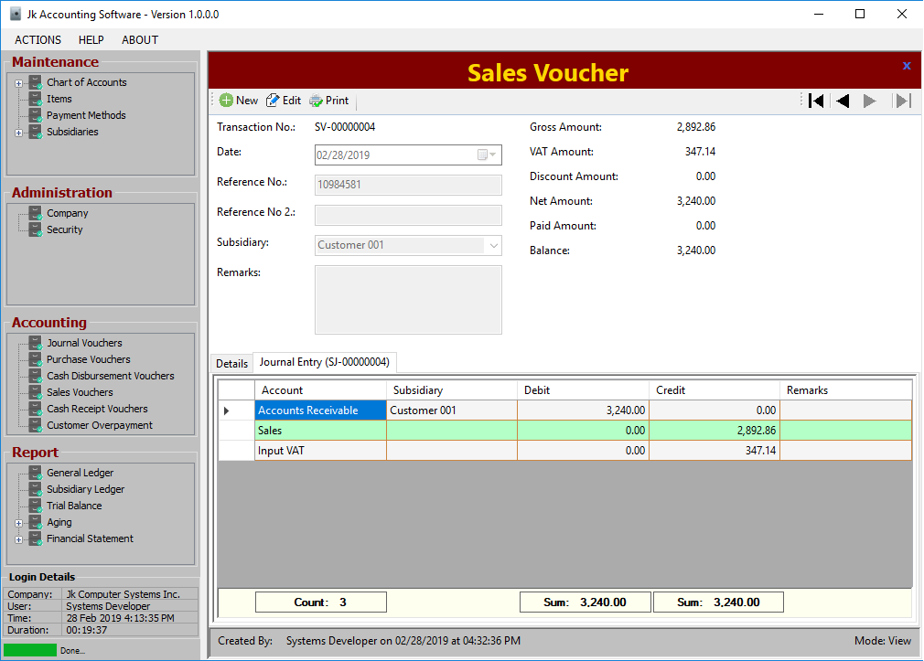
Then you can already print the Sales Invoice printout, by clicking Print button.

Sales Invoice printout, Page Width size
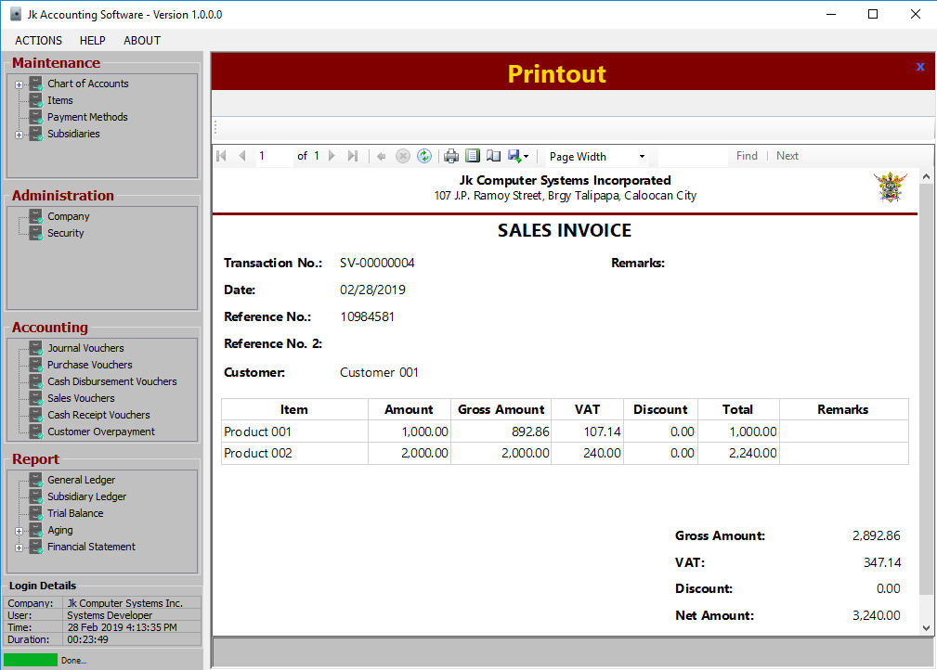
Sales Invoice printout, Page Width size on Print preview
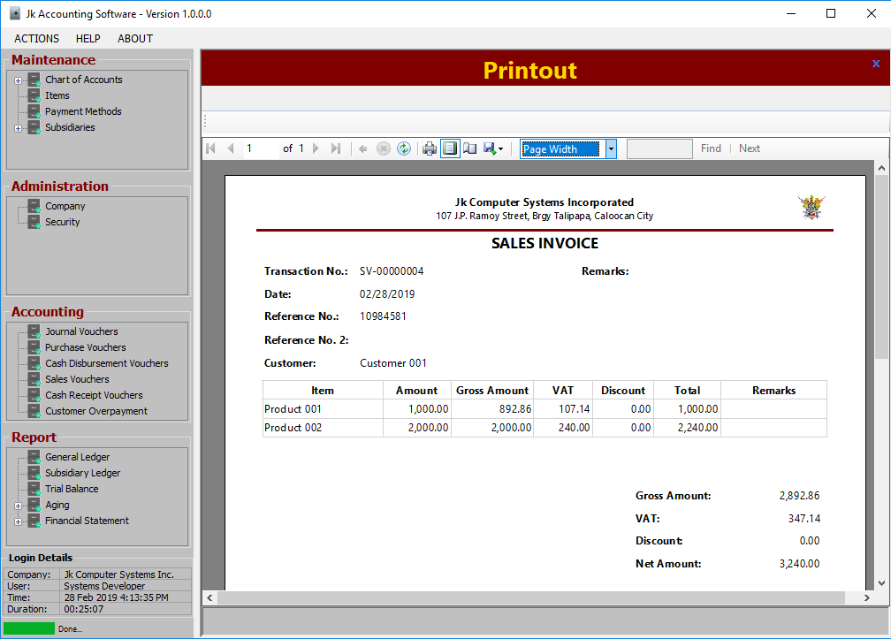
Sales Invoice printout, Whole Page size on Print preview
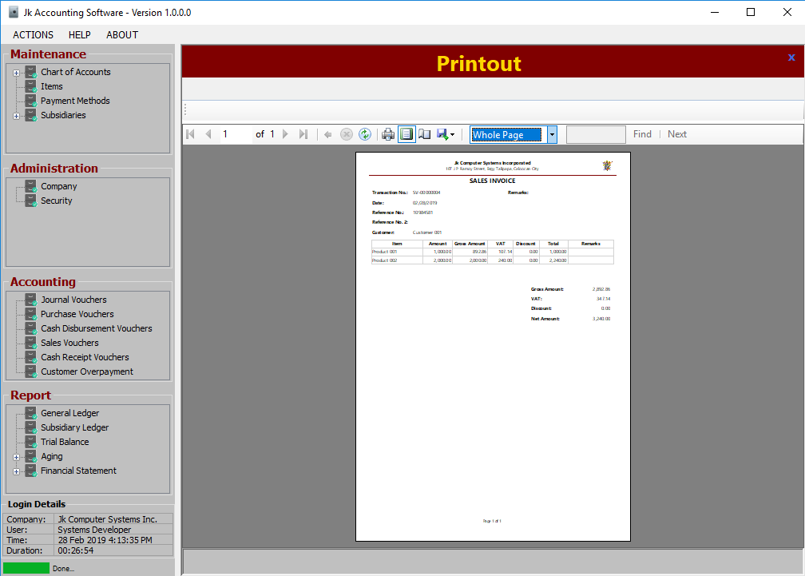Cash Receipt Vouchers – is used to record the receipt of payment from the sales of service or merchandise.
Purchase Vouchers – is used to record the procurement of sales or merchandise to a Supplier.
Cash Disbursement Vouchers – is used to record the payment for the procured service or merchandise.
Journal Vouchers – is used to record any transactions which doesn’t have a connection on sales, payment, procurement and disbursement.

The five transactions output the 5 books/journal of accounting which are Sales Journal, Cash Receipt Journal, Purchase Journal, Cash Disbursement Journal and General Journal.
11. Reports, composed mainly of accounting reports such as General Ledger, Subsidiary Ledger, Aging of Payables and Receivables and the most important are the Financial Statement report which are Income Statement, Balance Sheet and Cash Flow.

General Ledger – shows the distribution of debit and credit on chart of accounts in a specified date range, plus the beginning and ending balance.

General Ledger report, Default view
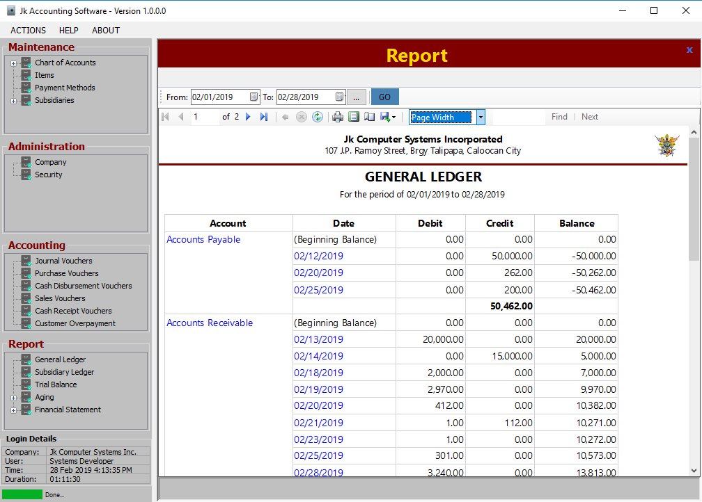
General Ledger report, Page Width size on Print preview
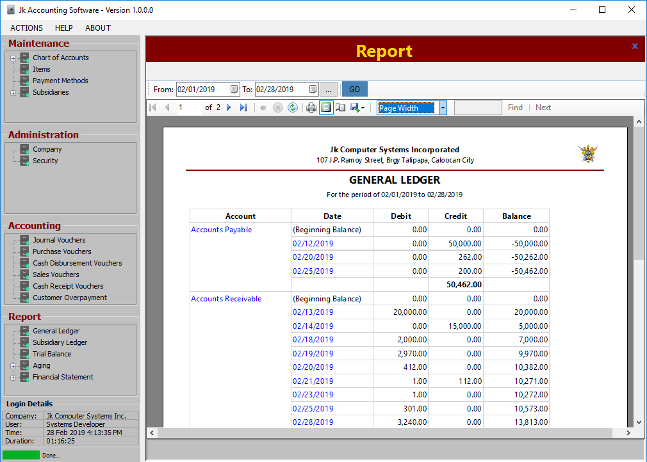
General Ledger report, Whole Page size on Print preview
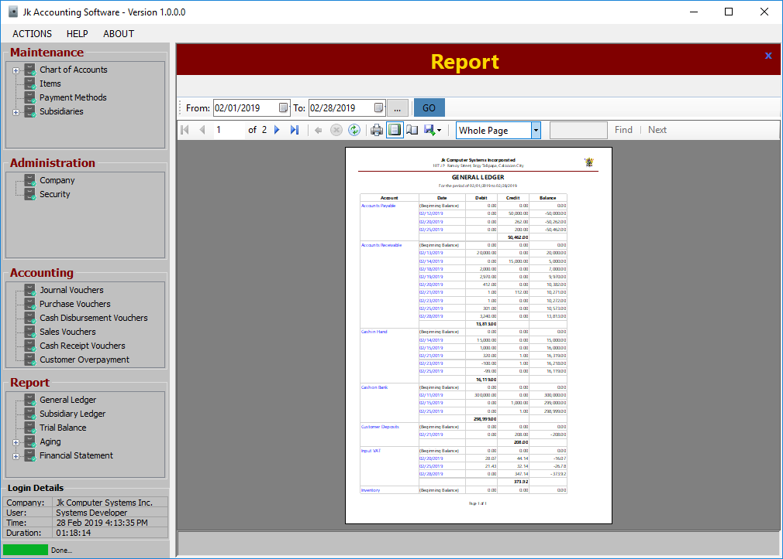
Accounts and Date fields can drilldown to the details of the transaction or the Journal.

General Ledger drilldown per Account, Default view
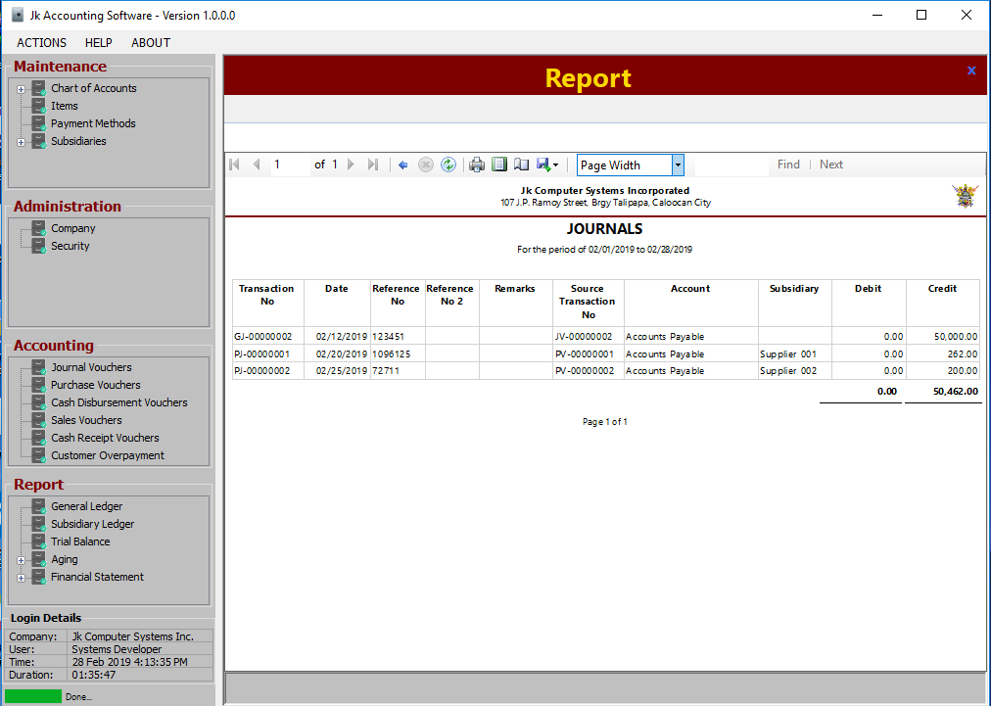
General Ledger drilldown per Account, Page Width size on Print preview
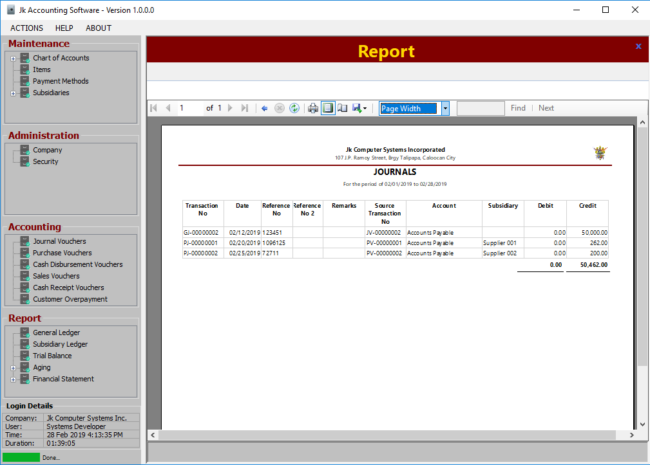
General Ledger drilldown per Account, Whole Page size on Print preview
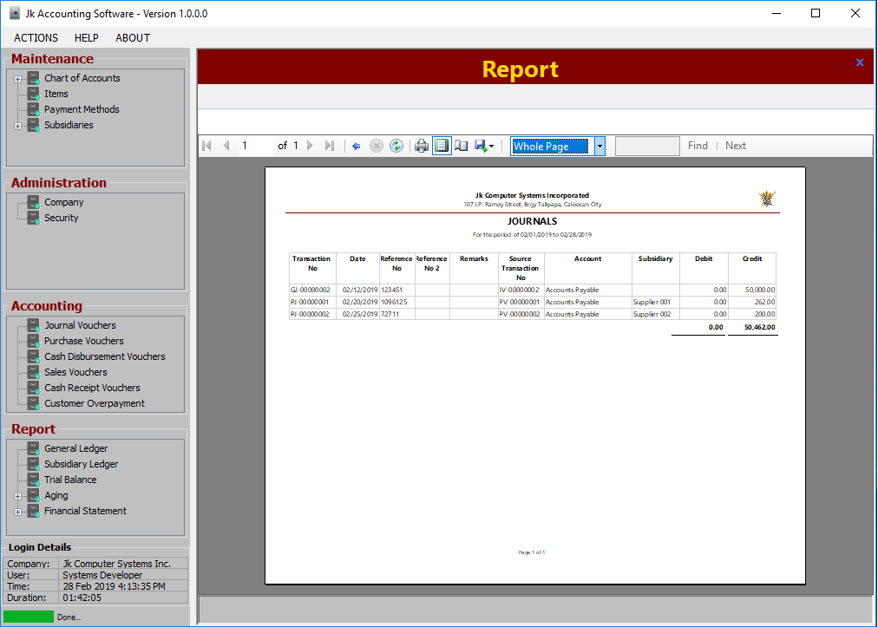
General Ledger drilldown per Date, Default view
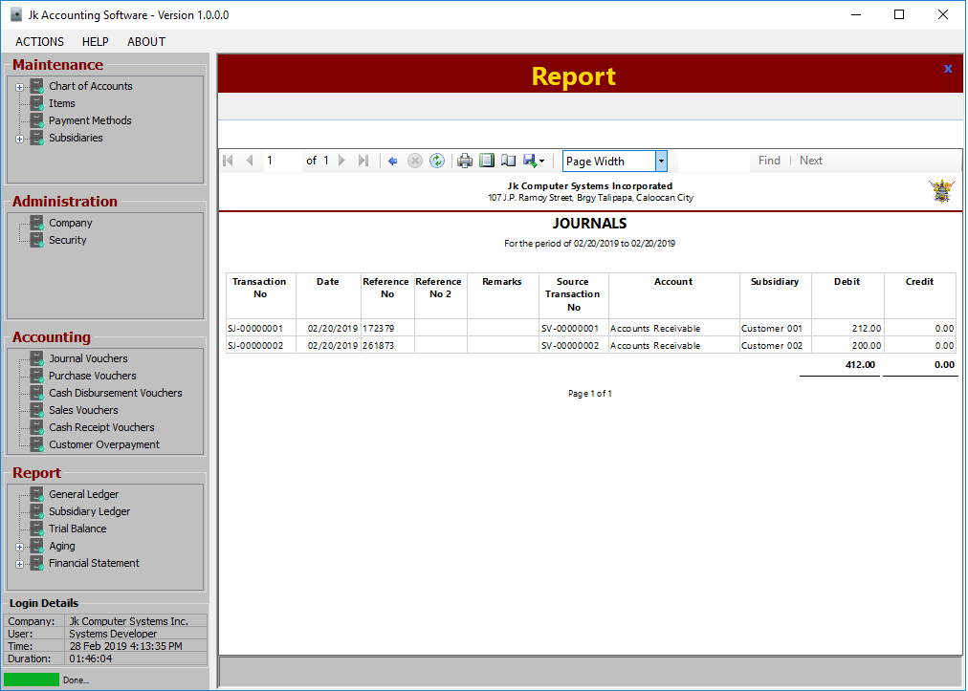
General Ledger drilldown per Date, Whole Page size on Print preview
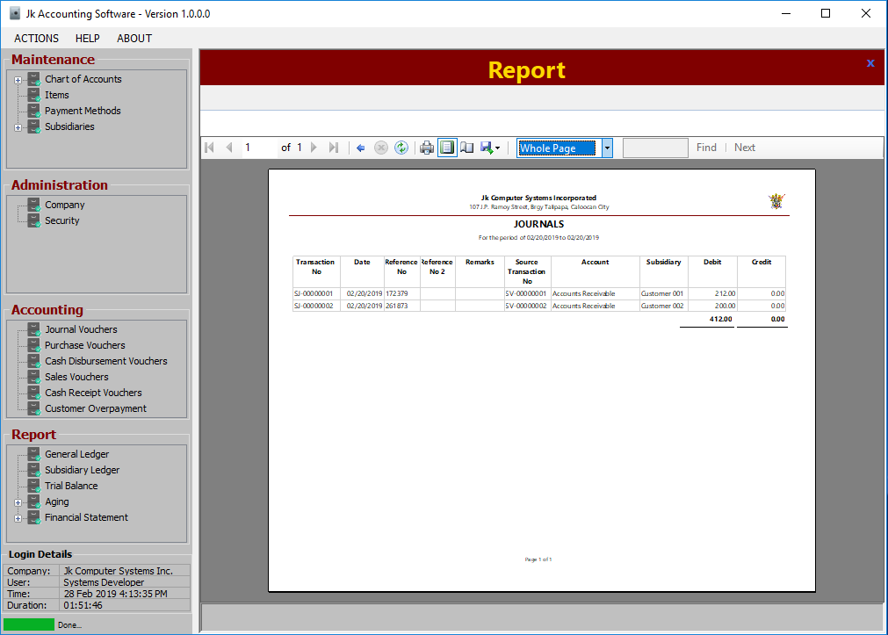
General Ledger drilldown per Date, Page Width size on Print preview
